**Custom DIO Vectors**

Use **abm**’s double-floxed inverse ORF (DIO) vectors for Cre-inducible expression of your gene-of interest! The DIO system allows you to express your target gene only in cells/tissues that also express the Cre recombinase protein, allowing for tissue-specific gene expression. This system is also called Cre-ON, Cre-Switch, FLEx-Cre, Flex-rev (reverse), or Flex-ON. We offer the DIO system in AAV and Lentivector formats.

* Adeno-Associated Virus (AAV) has low immunogenicity & pathogenicity (ideal for gene therapy), can target specific tissue types by using different serotypes, and infects dividing/non-dividing cells.
* Lentiviruses can infect both dividing and non-dividing cells and will integrate stably into the host cell genome, ensuring long-term expression even in cells that are difficult to infect

We also offer high-titer packaging services as well as Cre-expression AAVs and tamoxifen-inducible Cre Lentivirus to support your DIO project from cloning to expression.



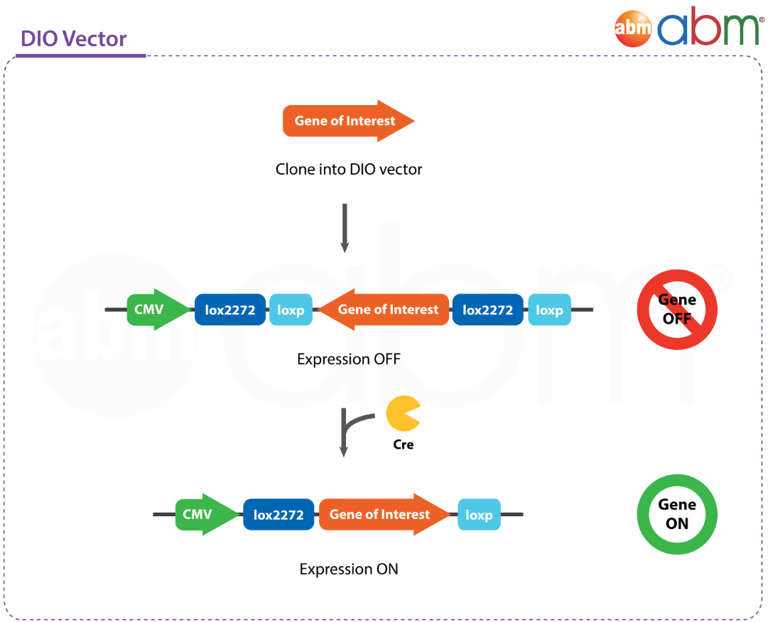

**Testimonial Box**: "Always amazed at the reasonable prices and breadth of selection for genes of interest available on your site. Thanks very much!"---Brian DeBosch, Washington University in St. Louis Chen

**Additional Resources:**

* Introduction to DIO

[https://www.abmgood.com/marketing/knowledge_base/Cre-Lox_Recombination.php]

* Introduction to Lentivirus [https://www.abmgood.com/marketing/knowledge_base/The_Lentivirus_System.php]
* Introduction to Adeno-Associated Virus

[https://www.abmgood.com/marketing/knowledge_base/Adeno_Associated_Virus_Introduction.php]

**Core Services:**

|  |  |  |  |
| --- | --- | --- | --- |
| **Service** | **Unit** | **Cat. No.** | **Price** |
| **Gene Synthesis** | Per bp | C098 | from USD $0.18/bp |
| **Vector Backbone for Cloning**  ***Lentivector Options:***  pLenti-GIII-CMV-DIO-SV40-Puro  **pLenti-GIII-CMV-DIO-SV40-copGFP**  *AAV Options:*  *pAAV-G-CMV-DIO*  pAAV-G-CMV-DIO-SV40-Puro  pAAV-G-CMV-DIO-SV40-copGFP | Not a Deliverable | C318 | $350.00 |
| Subcloning Service I | 1.0 μg | C096 | $125.00 |
| Promoter Change Service | 1.0 μg | C126 | $350.00 |
| Tag Addition/Removal Service (≤30bp) | 1.0 μg | C127 | $250.00 |

**Controls:**

|  |  |  |  |
| --- | --- | --- | --- |
| **Product** | **Unit** | **Cat. No.** | **Price** |
| Lenti-CMV-DIO-copGFP-SV40-Puro Vector | 1.0 μg | LV661 | $195.00 |
| Lenti-CMV-DIO-Blank-SV40-Puro Vector | 1.0 μg | LV662 | $195.00 |
| Lenti-CMV-DIO-Blank-SV40-copGFP Vector | 1.0 μg | LV663 | $195.00 |
| AAV-CMV-DIO-copGFP Vector | 1.0 μg | AAV101 | $195.00 |
| AAV-CMV-DIO-copGFP-SV40-Puro Vector | 1.0 μg | AAV102 | $195.00 |
| AAV-CMV-DIO-Blank-SV40-Puro Vector | 1.0 μg | AAV103 | $195.00 |
| AAV-CMV-DIO-Blank-SV40-copGFP Vector | 1.0 μg | AAV104 | $195.00 |

*Interested in Lentivirus Packaging and AAV Packaging options? Please inquire with us!*

**Our data speaks for itself:**

**Lenti:**

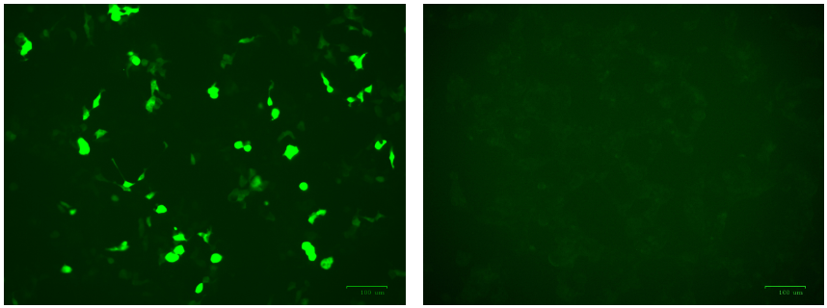

**Left:** 293 cells infected with Cat. No. LV661 Lenti-CMV-DIO-copGFP-SV40-Puro Vector showing copGFP expression in the presence of CRE  
**Right:** 293 cells infected with Cat. No. LV661 Lenti-CMV-DIO-copGFP-SV40-Puro Vector only (i.e. absence of CRE)

**AAV:**

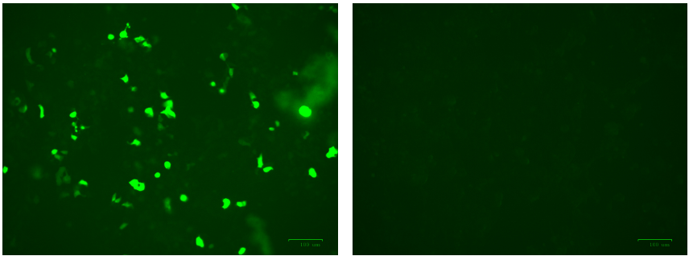

**Left:** 293 cells infected with Cat. No. AAV101 AAV-CMV-DIO-copGFP Vector showing copGFP expression in the presence of CRE  
**Right:** 293 cells infected with Cat. No. AAV101 AAV-CMV-DIO-copGFP Vector only (i.e. absence of CRE)

**Related Products:**

a) Name of product/service: Lentivirus Packaging Service

Link: [https://new.abmgood.com/Custom-Lentivirus-Subcloning-Services.html]

b) Name of product/service: AAV Packaging Service

Link: [https://new.abmgood.com/Custom-Adeno-Associated-Virus-AAV-Services.html]

c) Name of product/service: Cre Lentivirus

Link: [https://new.abmgood.com/catalogsearch/result/?q=ert2]

d) Name of product/service: Cre AAV

Link: [https://new.abmgood.com/Cre-AAV-5592310.html#aavp9625131]

**Documents:**

a) File Name: Viral Vector Brochure

Link: [https://www.abmgood.com/Documents/files/Viral-Vectors-Brochure-Single-Pages.pdf]

b) File Name: AAV – General Guideline to Serotype Selection

Link: [https://www.abmgood.com/Documents/files/AAV%20General%20Guideline%20to%20Serotype%20Selection%20V2.pdf]

c) File Name: AAV Infection Guideline

Link: [https://www.abmgood.com/Documents/files/AAV%20%20Infection%20%20Guideline.pdf]

d) File Name: Lentivirus Infection Guideline

Link: [https://www.abmgood.com/Documents/files/A4%20lenti%20infection-with%20spinoculation%20Nov%2024%202015.pdf]

**FAQs**

**Q:** Which virus has your lentivirus expression system been derived from? Is it HIV?

**A:** Our lentivirus expression system is derived from Human HIV-1 Virus. It employs third generation self-inactivating recombinant lentiviral vectors with enhanced biosafety features and minimal relation to wild-type Human HIV-1 Virus.

**Q:** Is your recombinant AAV replication-deficient?

**A:** Yes, the replication and capsid genes are provided in trans when the AAV is produced, therefore the packaged virion only has the ITR sequences and the gene of interest. Furthermore, the cis plasmid and rep/cap plasmid do not share any regions of homology, preventing the production of wild-type AAV through recombination system.

**Q:** Is AAV stable? What is the recommended storage temperature?

**A:** It is recommended to store AAV at -80˚C for long-term storage. For short-term, AAV is stable at 4˚C for up to three weeks without significant loss of activity.

**Citations**

*Coming soon!*